Ideation Phase
Define the Problem Statements

Date | 03 March 2026
Team ID | 69c0d687f58a227701cdf01d
Project Name | Streamlining Ticket Assignment for Efficient Supports Operations
Marks | 2 Marks

1.Ideal Situation (Expected State)
In an efficient support operation system, incoming tickets should be automatically and accurately assigned to the appropriate support agents based on issue type, priority, and expertise. This ensures faster resolution, balanced workload distribution, and improved customer satisfaction.
2.Current Situation (Existing Problem)
Currently, ticket assignment is largely manual or semi-automated, leading to:
- Incorrect ticket routing
- Delayed response times
- Uneven workload among support agents
- Lack of real-time visibility in ticket tracking
These inefficiencies slow down support operations and reduce overall service quality.
3.Gap Identification
There is a significant gap between the desired automated, intelligent ticket assignment system and the current manual, error-prone process.
This gap results from:
- Absence of intelligent classification mechanisms
- Limited automation in workflow processes
- Dependency on human decision-making for routing
4.Impact / Consequences
The existing challenges lead to:
- Increased ticket resolution time
- Reduced productivity of support teams
- Poor customer experience and satisfaction
A problem statement must clearly highlight such impacts to justify improvement efforts.
5.Problem Statement (Final Statement)
Support teams need an efficient and automated way to assign incoming tickets accurately and quickly because the current manual assignment process leads to delays, misrouting, and uneven workload distribution, resulting in reduced operational efficiency and poor customer satisfaction.
6.Scope for Ideation
The ideation phase will focus on generating innovative solutions such as:
- Automated ticket routing systems
- AI/ML-based ticket classification
- Rule-based workflow automation
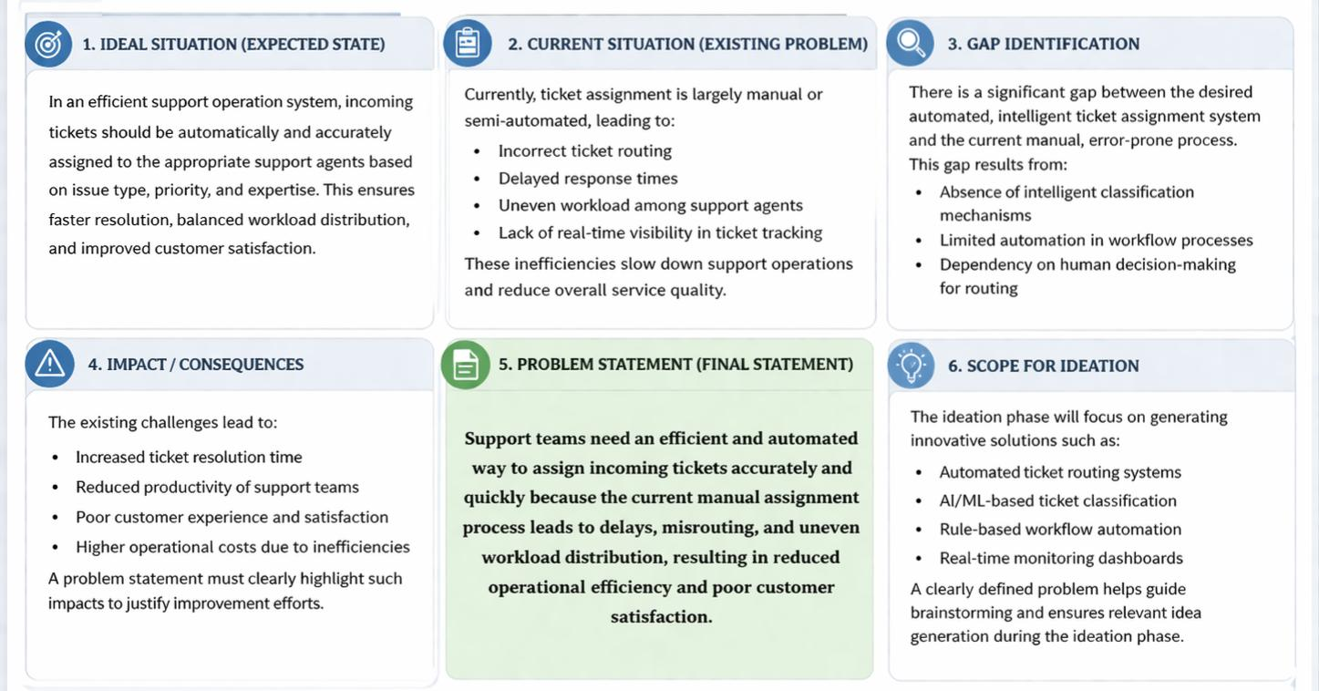
- Real-time monitoring dashboards

